Plane Surface

Definition
# Source: AI Source: Provided by: [Data Path: Persons Table -> ID Column: 1, Name_En Column: Motasem Essam] -> From: [ChatGPT] on [7/20/2026]
A plane surface is a flat, two-dimensional surface in which any straight line segment connecting two points on the surface lies entirely within the surface.
In Euclidean Geometry, a plane is an ideal geometric surface that:
- Extends infinitely in two dimensions.
- Has length and width.
- Has no thickness.
- Is perfectly flat.
- Has zero curvature.
A plane is commonly represented by a capital letter, such as Plane $P$, or by three non-collinear points:
$$\text{Plane }ABC$$
where $A$, $B$, and $C$do not lie on the same line.
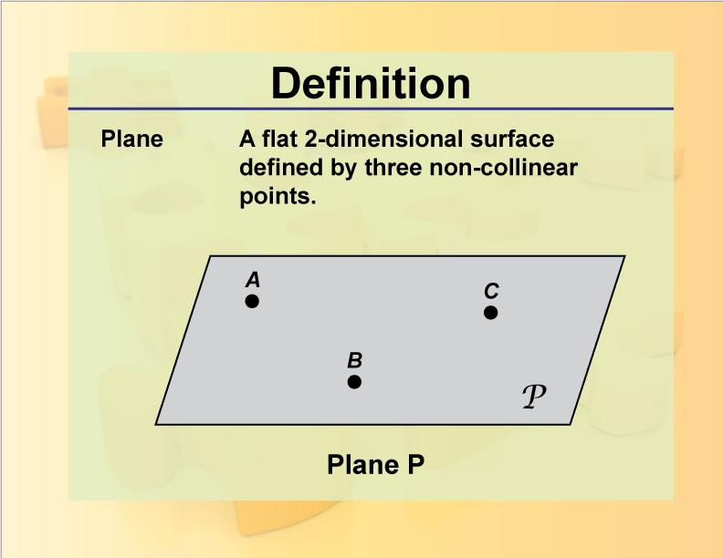
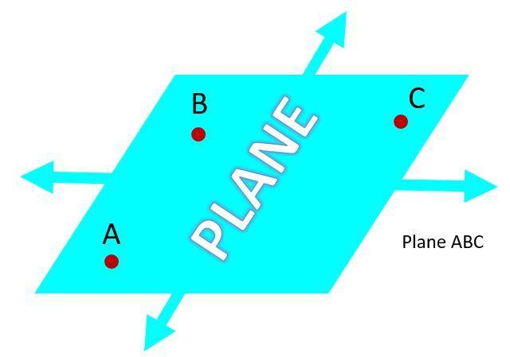
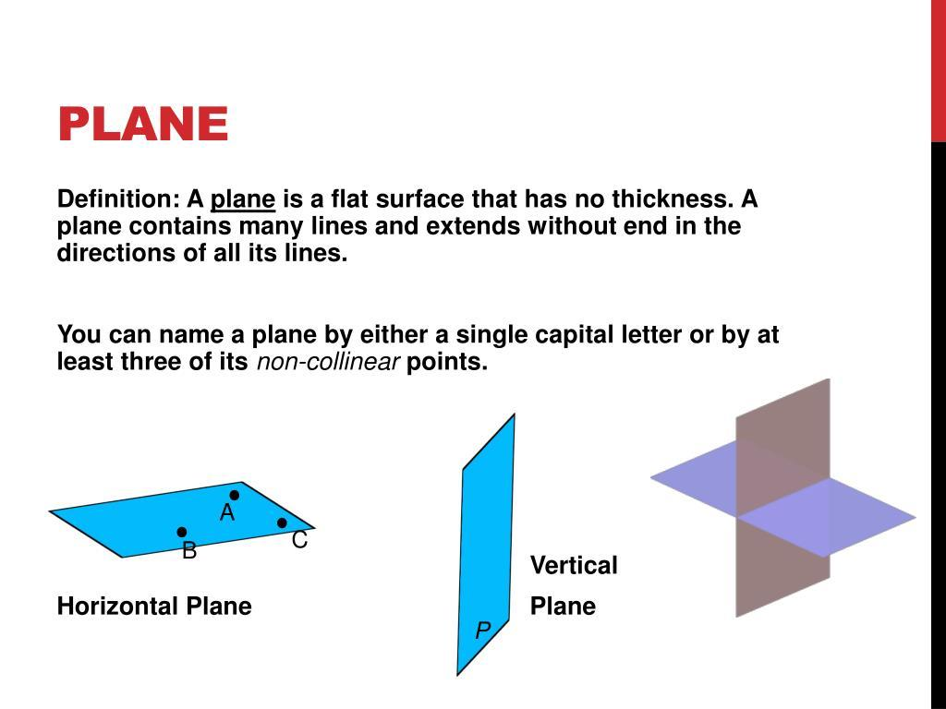
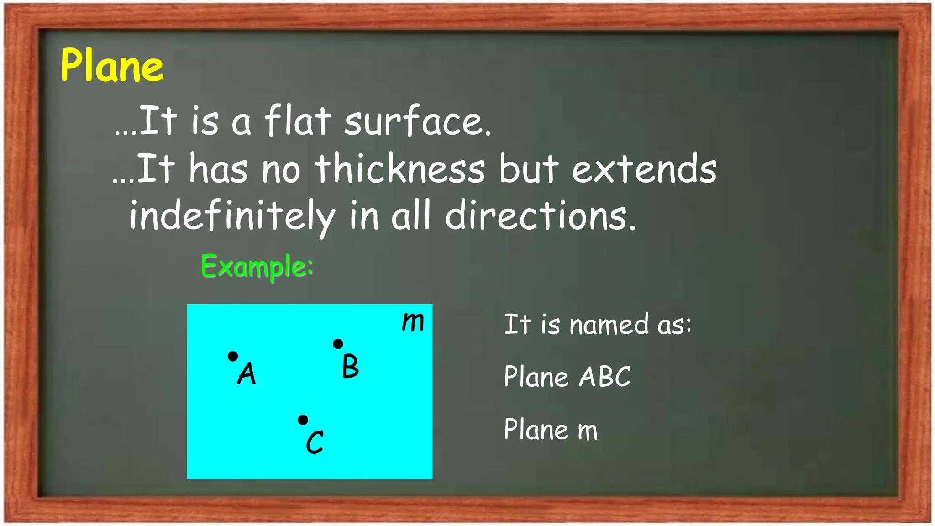
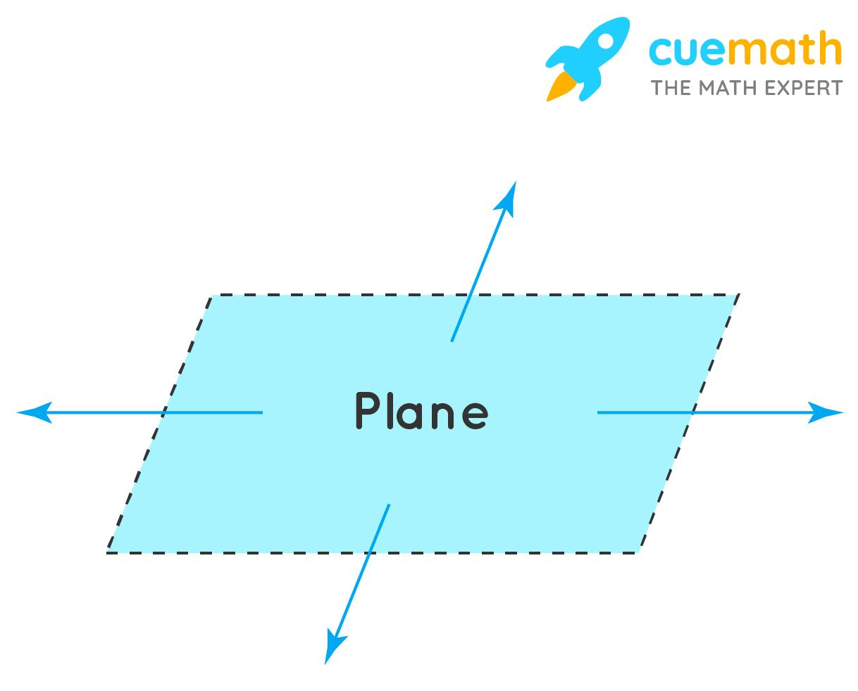

Purpose
# Source: AI Source: Provided by: [Data Path: Persons Table -> ID Column: 1, Name_En Column: Motasem Essam] -> From: [ChatGPT] on [7/20/2026]
A plane surface provides a two-dimensional setting in which geometric objects and relationships can be studied.
It is used to:
- Define and study points, lines, and angles.
- Study plane figures such as triangles and quadrilaterals.
- Measure length, perimeter, and area.
- Study parallel and perpendicular relationships.
- Establish the foundation of Plane Geometry.
- Represent flat surfaces in three-dimensional space.

Fundamental Elements
# Source: AI Source: Provided by: [Data Path: Persons Table -> ID Column: 1, Name_En Column: Motasem Essam] -> From: [ChatGPT] on [7/20/2026]
A plane surface can contain infinitely many geometric objects.
Points
Any number of points can lie on a plane:
$$A, B, C, D,…$$
Lines
A line can lie completely within a plane:
$$\overset{↔}{AB}$$
Line Segments
A line segment connecting two points on a plane also lies within the plane:
$$\overset{‾}{AB}$$
Rays
A ray can also lie entirely within the plane:
$$\vec{AB}$$
Angles
Two rays lying in the same plane can form a plane angle:
$$∠ABC$$
Plane Figures
Many two-dimensional figures are contained in a plane, including:
- Triangles
- Quadrilaterals
- Polygons
- Circles

Mathematical Representation
# Source: AI Source: Provided by: [Data Path: Persons Table -> ID Column: 1, Name_En Column: Motasem Essam] -> From: [ChatGPT] on [7/20/2026]
In coordinate geometry, a plane in three-dimensional Cartesian space can be represented by:
$$ax+by+cz=d$$
where $a$, $b$, $c$, and $d$are constants and $a$, $b$, and $c$are not all zero.
For example:
$$2x+3y+z=6$$
represents a plane in three-dimensional space.
For ordinary Plane Geometry, we commonly use a two-dimensional coordinate plane:
$$\left(x , y\right)$$
with the two coordinate axes:
$$x\text{-axis}$$
and
$$y\text{-axis}$$
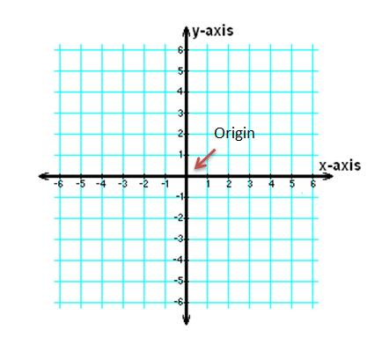
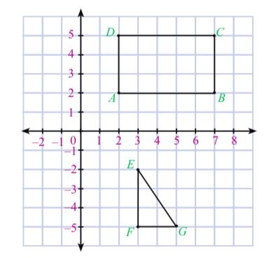
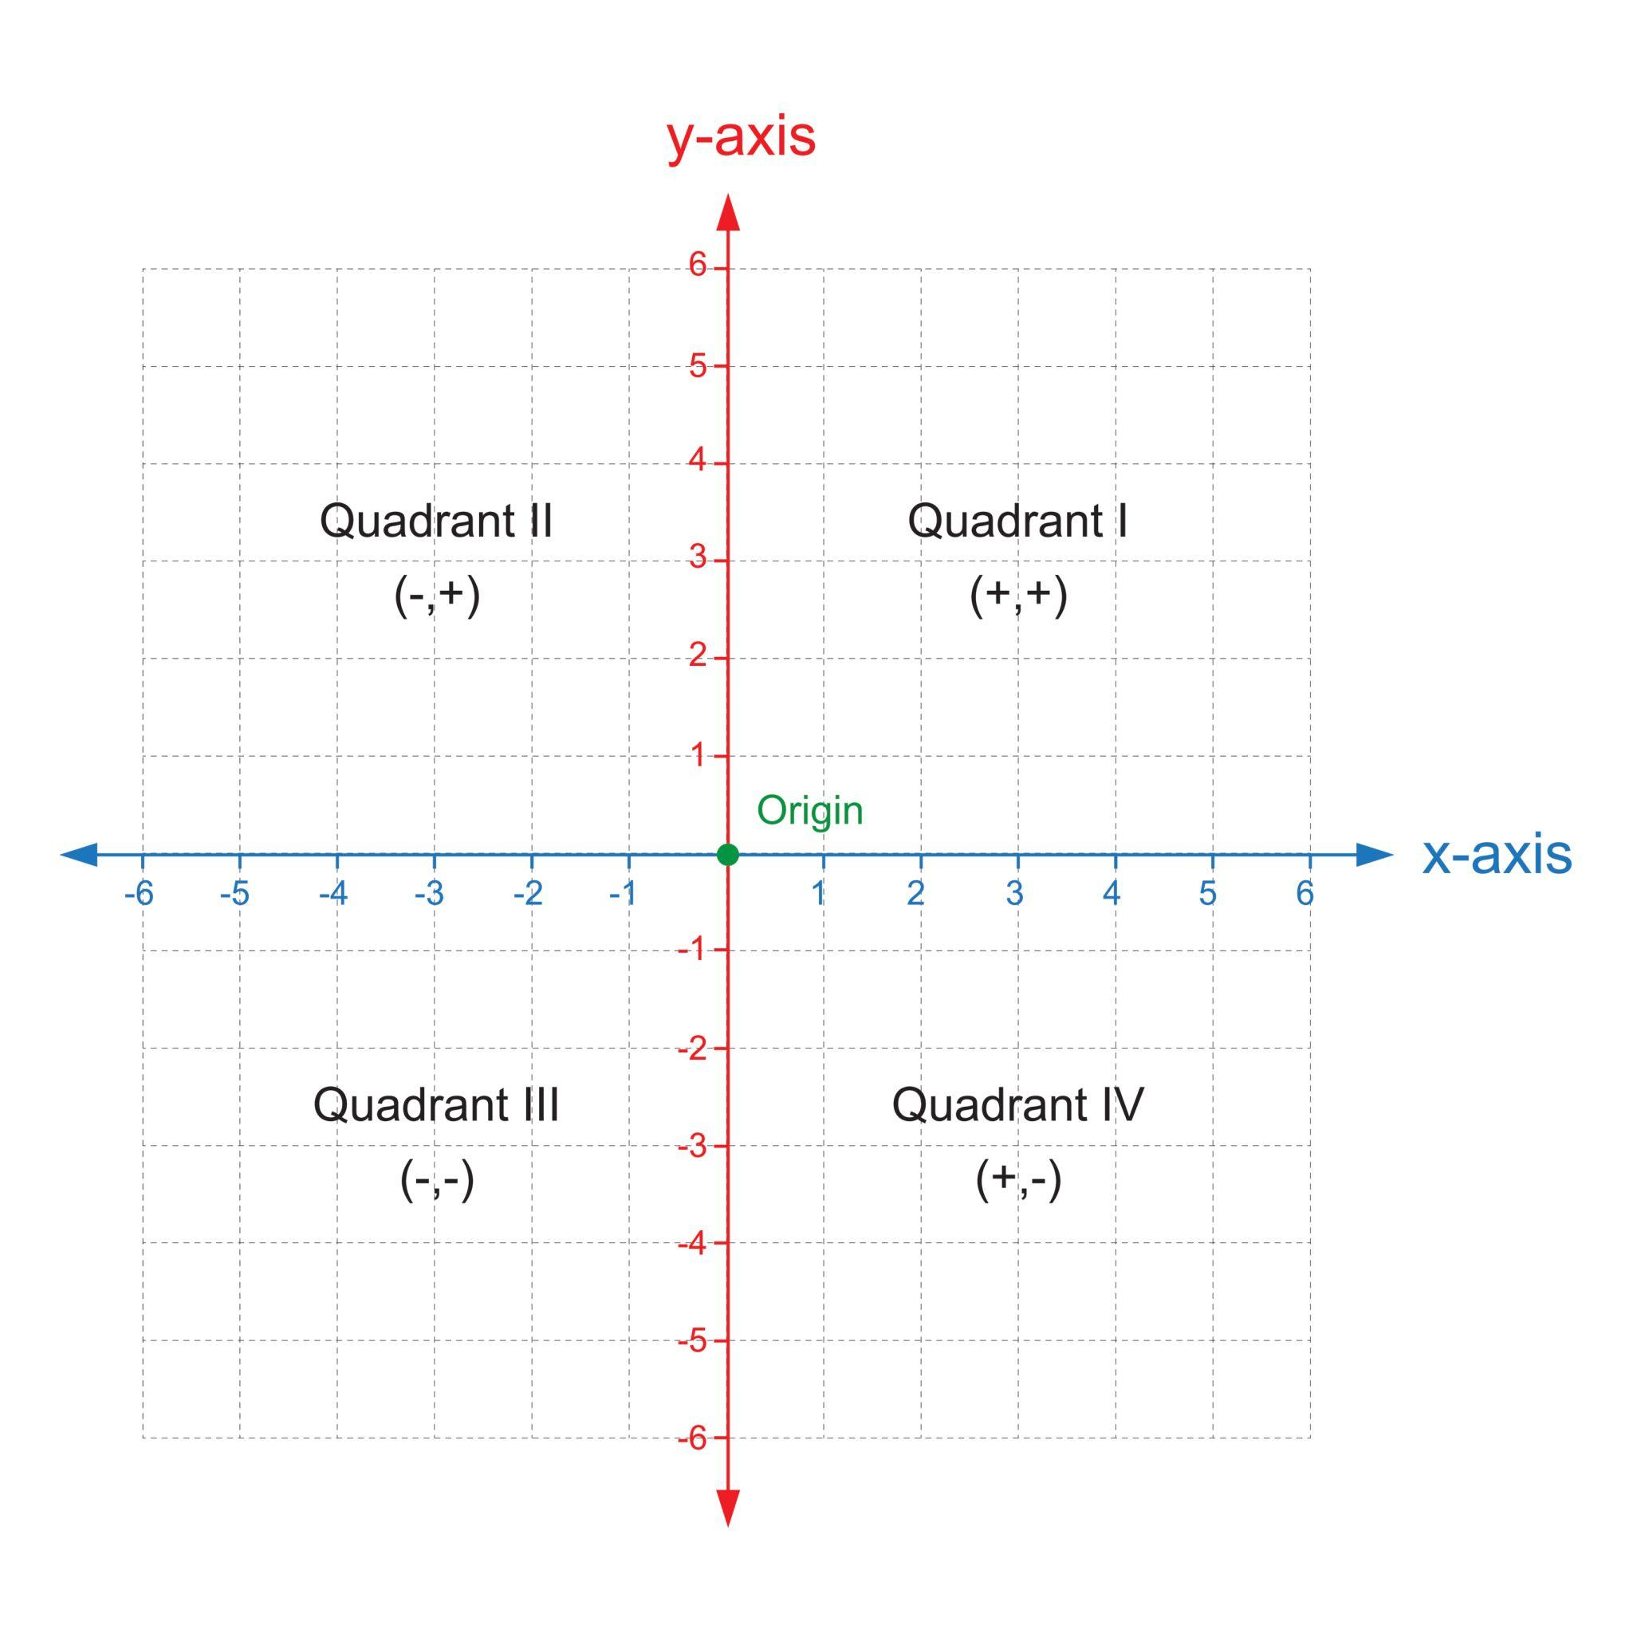

Properties of a Plane Surface

1. Flatness
# Source: AI Source: Provided by: [Data Path: Persons Table -> ID Column: 1, Name_En Column: Motasem Essam] -> From: [ChatGPT] on [7/20/2026]
A plane surface is perfectly flat.
It does not bend or curve.

2. Two-Dimensional
# Source: AI Source: Provided by: [Data Path: Persons Table -> ID Column: 1, Name_En Column: Motasem Essam] -> From: [ChatGPT] on [7/20/2026]
A plane has two dimensions:
$$\boxed{\text{Length and Width}}$$
It does not have geometric thickness.

3. Infinite Extent
# Source: AI Source: Provided by: [Data Path: Persons Table -> ID Column: 1, Name_En Column: Motasem Essam] -> From: [ChatGPT] on [7/20/2026]
A mathematical plane extends infinitely in every direction within the plane.
A drawing of a plane is therefore only a small representation of an infinite object.

4. Zero Curvature
# Source: AI Source: Provided by: [Data Path: Persons Table -> ID Column: 1, Name_En Column: Motasem Essam] -> From: [ChatGPT] on [7/20/2026]
A plane has zero intrinsic curvature.
$$\boxed{\text{Curvature}=0}$$
This distinguishes it from curved surfaces such as spheres and cylinders.

5. Contains Infinitely Many Points
# Source: AI Source: Provided by: [Data Path: Persons Table -> ID Column: 1, Name_En Column: Motasem Essam] -> From: [ChatGPT] on [7/20/2026]
A plane contains infinitely many points.

6. Contains Infinitely Many Lines
# Source: AI Source: Provided by: [Data Path: Persons Table -> ID Column: 1, Name_En Column: Motasem Essam] -> From: [ChatGPT] on [7/20/2026]
Infinitely many different lines can lie within the same plane.

7. Three Non-Collinear Points Determine a Plane
# Source: AI Source: Provided by: [Data Path: Persons Table -> ID Column: 1, Name_En Column: Motasem Essam] -> From: [ChatGPT] on [7/20/2026]
Exactly one plane can pass through three non-collinear points.
For example:
$$A, B, C$$
determine a unique plane if they are not collinear.
$$\boxed{\text{Three non-collinear points determine exactly one plane.}}$$

8. A Line and a Point Outside the Line Determine a Plane
# Source: AI Source: Provided by: [Data Path: Persons Table -> ID Column: 1, Name_En Column: Motasem Essam] -> From: [ChatGPT] on [7/20/2026]
A line and a point not lying on that line determine exactly one plane.

Plane Surface vs Physical Flat Surface
# Source: AI Source: Provided by: [Data Path: Persons Table -> ID Column: 1, Name_En Column: Motasem Essam] -> From: [ChatGPT] on [7/20/2026]
A mathematical plane should not be confused with an actual physical surface.
For example:
- A sheet of paper is approximately flat.
- A tabletop is approximately flat.
- A wall is approximately flat.
But none of them is an actual infinite mathematical plane.
They are physical models or approximations of a plane.

Examples

Example 1 — Sheet of Paper
# Source: AI Source: Provided by: [Data Path: Persons Table -> ID Column: 1, Name_En Column: Motasem Essam] -> From: [ChatGPT] on [7/20/2026]
A flat sheet of paper can be used as a physical model of a plane surface.
The paper has finite dimensions, while a mathematical plane extends infinitely.

Example 2 — Coordinate Plane
# Source: AI Source: Provided by: [Data Path: Persons Table -> ID Column: 1, Name_En Column: Motasem Essam] -> From: [ChatGPT] on [7/20/2026]
The $xy$-plane is a plane defined by:
$$z=0$$
Every point on this plane has coordinates of the form:
$$\left(x , y , 0\right)$$
For example:
$$A\left(2 , 3 , 0\right)$$
lies on the $xy$-plane.

Example 3 — Triangle on a Plane
# Source: AI Source: Provided by: [Data Path: Persons Table -> ID Column: 1, Name_En Column: Motasem Essam] -> From: [ChatGPT] on [7/20/2026]
Suppose three points are:
$$A\left(0 , 0\right), B\left(4 , 0\right), C\left(0 , 3\right)$$
These points form:
$$△ABC$$
The triangle lies entirely within the plane.
Its area is:
$$A=\frac{1}{2}\left(4\right)\left(3\right)=6$$
square units.

Plane Surface and Plane Geometry
# Source: AI Source: Provided by: [Data Path: Persons Table -> ID Column: 1, Name_En Column: Motasem Essam] -> From: [ChatGPT] on [7/20/2026]
A plane surface is the fundamental setting for Plane Geometry.
A useful relationship is:
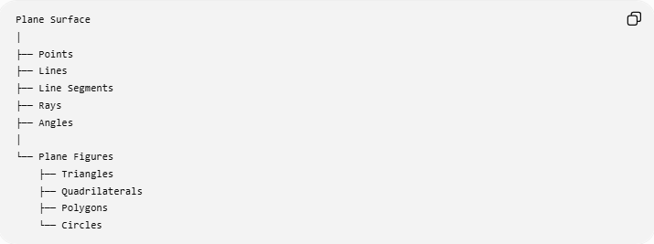
Plane Surface
│
├── Points
├── Lines
├── Line Segments
├── Rays
├── Angles
│
└── Plane Figures
├── Triangles
├── Quadrilaterals
├── Polygons
└── Circles
Therefore:
$$\boxed{\text{Plane Geometry studies geometric objects and relationships within a plane.}}$$

Plane Surface vs Curved Surface
# Source: AI Source: Provided by: [Data Path: Persons Table -> ID Column: 1, Name_En Column: Motasem Essam] -> From: [ChatGPT] on [7/20/2026]
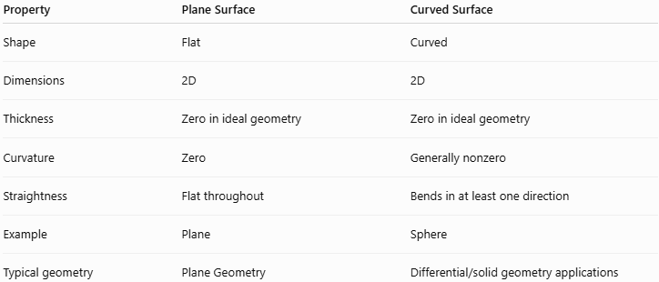
Property | Plane Surface | Curved Surface
Shape | Flat | Curved
Dimensions | 2D | 2D
Thickness | Zero in ideal geometry | Zero in ideal geometry
Curvature | Zero | Generally nonzero
Straightness | Flat throughout | Bends in at least one direction
Example | Plane | Sphere
Typical geometry | Plane Geometry | Differential/solid geometry applications
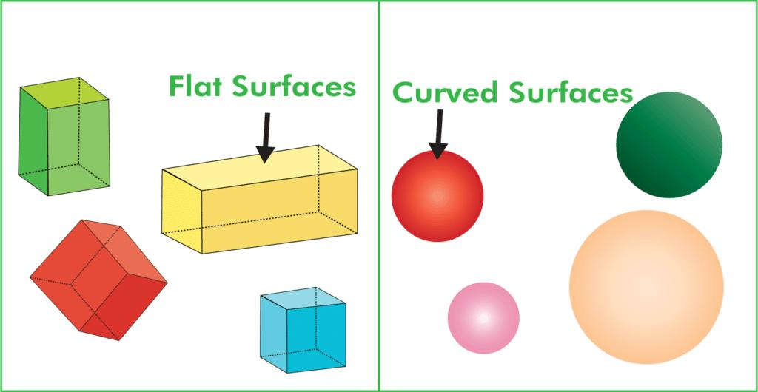
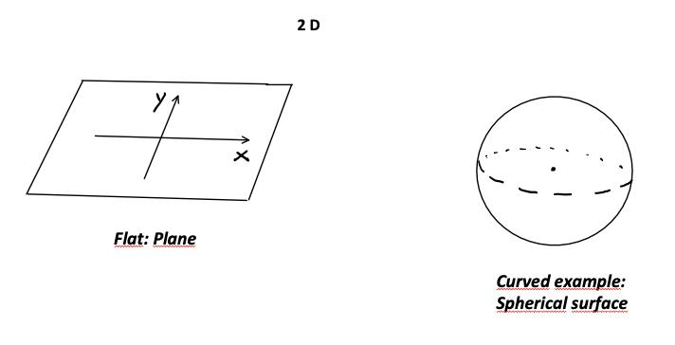
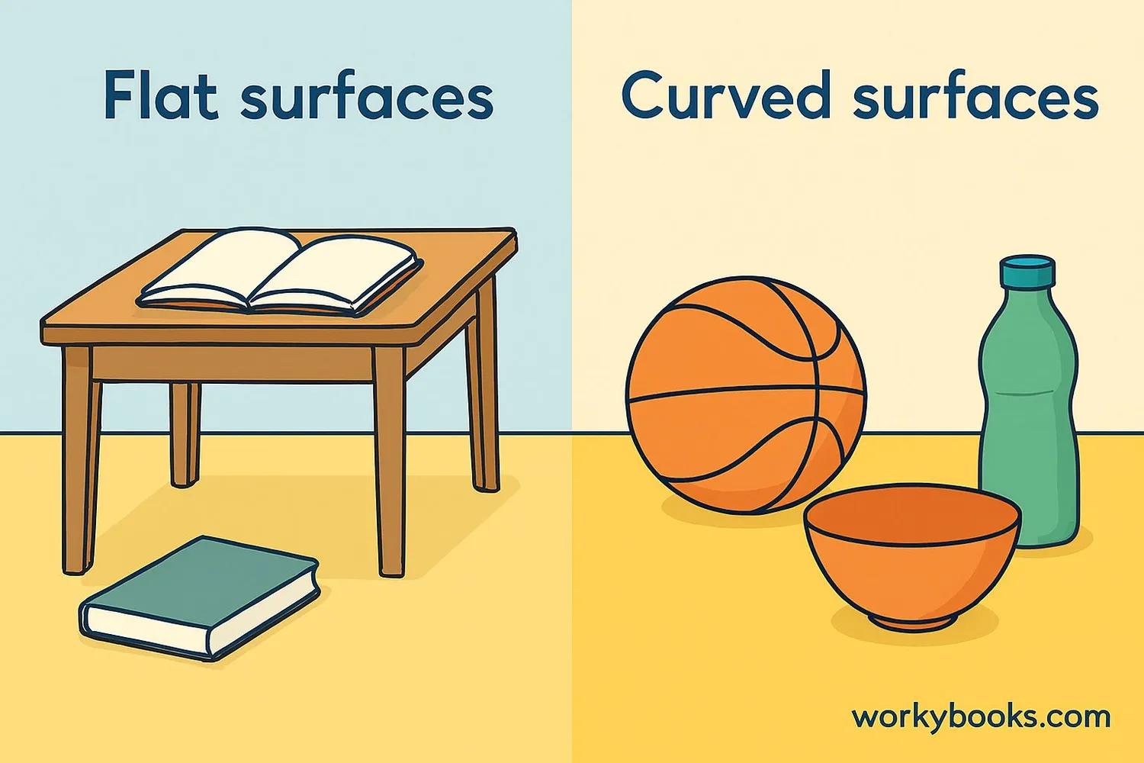
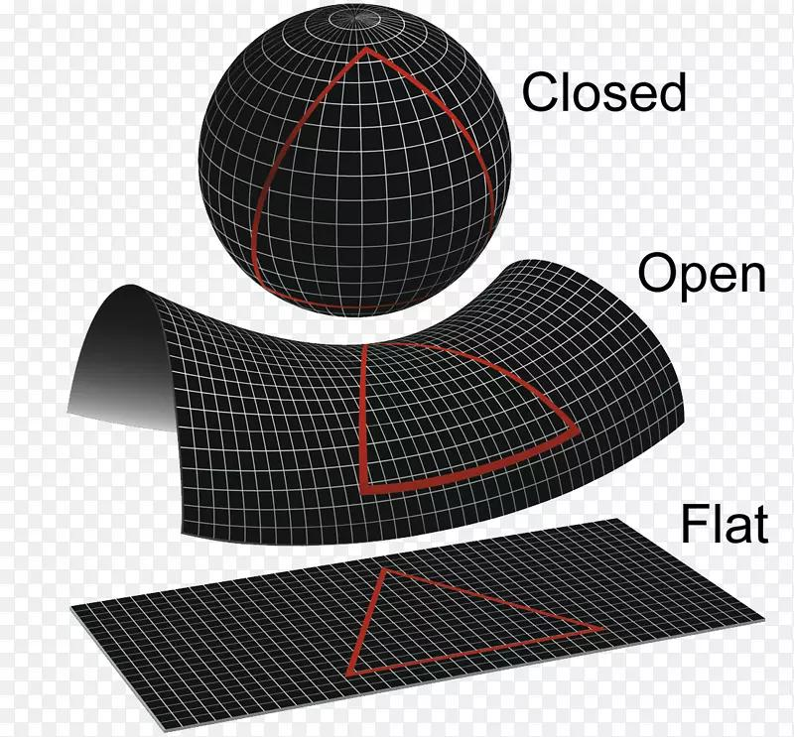
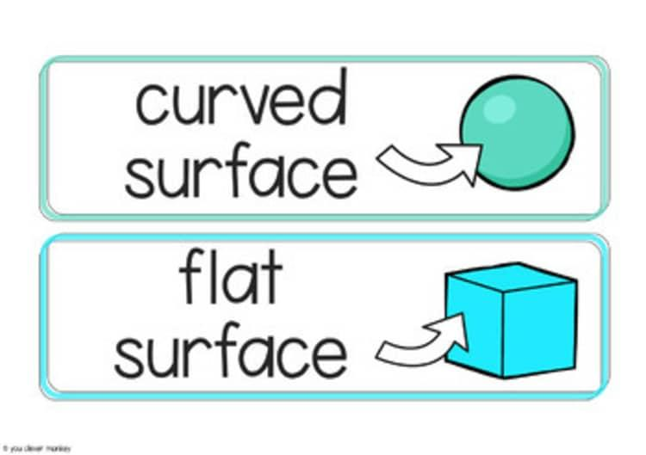

Plane Surface vs Plane
# Source: AI Source: Provided by: [Data Path: Persons Table -> ID Column: 1, Name_En Column: Motasem Essam] -> From: [ChatGPT] on [7/20/2026]
These terms are closely related but should be distinguished.
Plane
A plane is the ideal mathematical object used in Euclidean Geometry.
Plane Surface
A plane surface emphasizes the flat two-dimensional surface represented by a plane.
In elementary geometry, the two terms are often used almost interchangeably.
For your knowledge base, I recommend:
$$\boxed{\text{Plane Surface}→\text{Type of Surface}}$$
while:
$$\boxed{\text{Plane}→\text{Fundamental Geometric Concept}}$$

Real-World Applications
# Source: AI Source: Provided by: [Data Path: Persons Table -> ID Column: 1, Name_En Column: Motasem Essam] -> From: [ChatGPT] on [7/20/2026]
Plane surfaces are used to model:
- Walls
- Floors
- Ceilings
- Tables
- Sheets of paper
- Glass panels
- Machine surfaces
- Architectural surfaces
- Engineering drawings
- Maps
In engineering and manufacturing, a surface may be designed to be sufficiently flat according to a specified flatness tolerance.

Relationship with Other Concepts
# Source: AI Source: Provided by: [Data Path: Persons Table -> ID Column: 1, Name_En Column: Motasem Essam] -> From: [ChatGPT] on [7/20/2026]
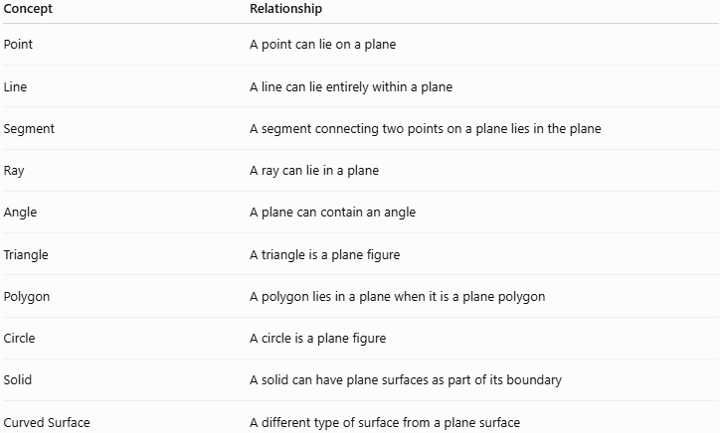
Concept | Relationship
Point | A point can lie on a plane
Line | A line can lie entirely within a plane
Segment | A segment connecting two points on a plane lies in the plane
Ray | A ray can lie in a plane
Angle | A plane can contain an angle
Triangle | A triangle is a plane figure
Polygon | A polygon lies in a plane when it is a plane polygon
Circle | A circle is a plane figure
Solid | A solid can have plane surfaces as part of its boundary
Curved Surface | A different type of surface from a plane surface

Key Points
# Source: AI Source: Provided by: [Data Path: Persons Table -> ID Column: 1, Name_En Column: Motasem Essam] -> From: [ChatGPT] on [7/20/2026]
- A plane surface is a flat two-dimensional surface.
- It has length and width but no thickness in ideal geometry.
- It extends infinitely in the mathematical model.
- Its curvature is zero.
- Three non-collinear points determine a unique plane.
- Plane figures such as triangles, quadrilaterals, polygons, and circles can lie on a plane.
- A physical flat object is only an approximation of a mathematical plane.
- Plane Surface is a type of Surface, while Plane is a fundamental geometric concept.

Conclusion
# Source: AI Source: Provided by: [Data Path: Persons Table -> ID Column: 1, Name_En Column: Motasem Essam] -> From: [ChatGPT] on [7/20/2026]
A plane surface is the flat, two-dimensional type of surface that forms the fundamental setting for Plane Geometry. It contains points, lines, segments, rays, angles, and plane figures, and it provides the mathematical framework for studying flat geometric relationships and measurements.

